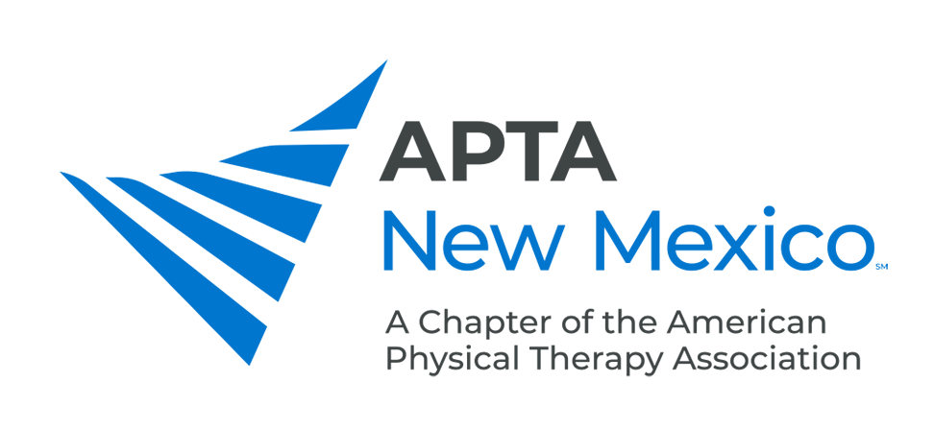

AWARDS NOMINATION FORM

The following individual is nominated for consideration of (check one):

_______ PT or PTA of the Year Award
_______ Community Service Award

Name: __________________________________________________________________ APTA Membership #: ___________________

Address: ___________________________________________________________________________________________________________

City, State, Zip: _______________________________________________________________________________________________________

Phone: ___________________________________________ E-Mail: ___________________________________________________________

Nominator: _______________________________________________________________ APTA Membership #: ___________________

Address: ___________________________________________________________________________________________________________

City, State, Zip: _______________________________________________________________________________________________________

Phone: ___________________________________________ E-Mail: ___________________________________________________________

____ Check here if you would like the nomination to be considered for next year in the event the individual is not selected this year.

Please send the Nomination Form and letter(s) of support by August 1 to: info@nmapta.org


AWARDS

PT or PTA of the Year

Eligibility Criteria:

- Member of APTA New Mexico for the previous 18 months.
- A practicing PT or PTA for 4 years.

Selection Criteria:

- Must have made an outstanding contribution to the physical therapy profession or the community.

Areas to be considered may include:

- Patient Care
- Education
- Research
- Communications/Publications
- Service to APTA or APTA New Mexico
- Leadership

- Must demonstrate and maintain high personal and professional standards and serve as a role model for other professionals.

Community Service Award

Eligibility Criteria:

- Member of APTA New Mexico for the previous 12 months.
- PT or PTA

Selection Criteria:

- Contributions should be of exceptional value to the nominee’s community/state.
- Services that are performed for remuneration will not be considered.
- Past and present involvement in community service activities will be considered.

Areas to be considered may include:

- Teaching
- Political Involvement
- Religious Activities
- Coaching
- Community Education

- Must demonstrate and maintain high personal and professional standards and serve as a role model for other professionals.

